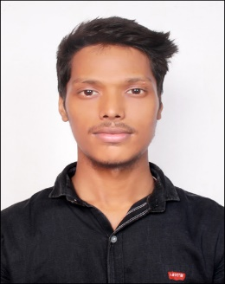**ABHISHEK DUBEY**

136D railway colomy, Mirzapur, pin code- 231001

Email- abhishekdubey1191997@gmail.com

Contact no:- +917754916686

DOB:- 11/09/1997

**Career Objective:**  
  
To gain a platform to leverage my skills and academically acquired knowledge to excel in my chosen field and to take my company to a higher level of excellence gradually, being given the right environment. I am a simple person with rich and scientific personal and team goals.

**ACADEMIC DETAILS:**

|  |  |  |  |  |
| --- | --- | --- | --- | --- |
| **DEGREE** | **INSTITUTION** | **BOARD** | **YEAR**  **OF**  **PASSING** | **PERCENTAGE** |
| **B.A.** | G.S.Y. Mahavidhyalay | MGKVP | **2018** | **48%** |
| **Intermidiate** | GOVT INTER COLLEGE | UP | **2014** | **70%** |
| **Highschool** | JP PUBLIC SCHOOL | UP | **2012** | **69.5%** |

**Strength**

* Can work under stressed situations.
* Disciplined & Creative
* Loyal towards work.
* Polite and patience nature.
* Self confidence

**Achievements**

* Have participated and won many cricket event.
* Have participated in many college level dance event.

**Hobbies**

* Dancing.
* Playing cricket.
* Doing something creative.

**DECLARATION:**

I hereby declare that the above written particulars are true to the

best of my knowledge

**ABHISHEK DUBEY**